Spring Boot:

1- Dependencies: jar file which we use to run a framework

2- Maven: build tool which is used to download jar files automatically

Creating project

Tool which is used to create Spring boot project structure: Spring initializer

*Spring_Web is the dependency which is must for a Spring boot project.

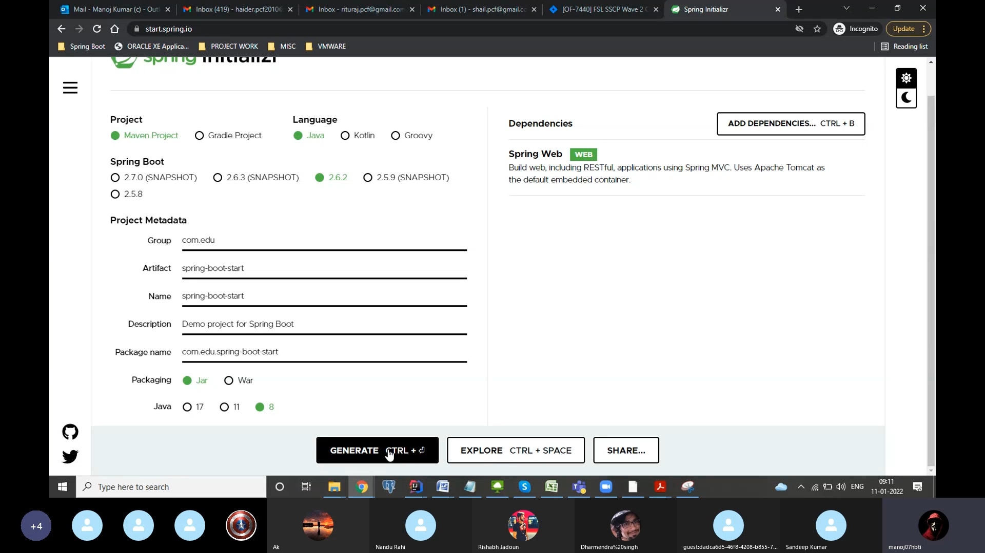

1- check dependencies

2- check maven dependencies

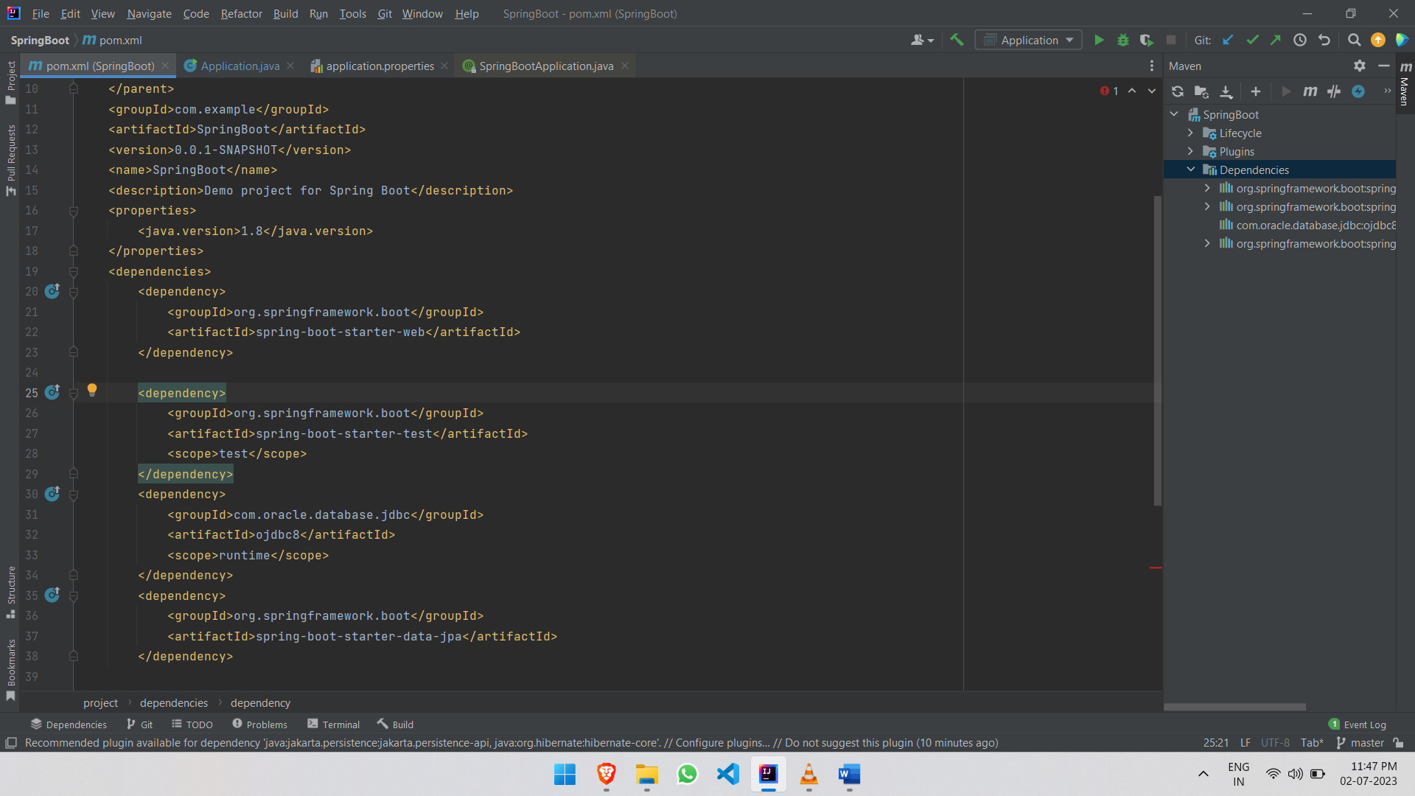

To change server port

(default server port is 8080)

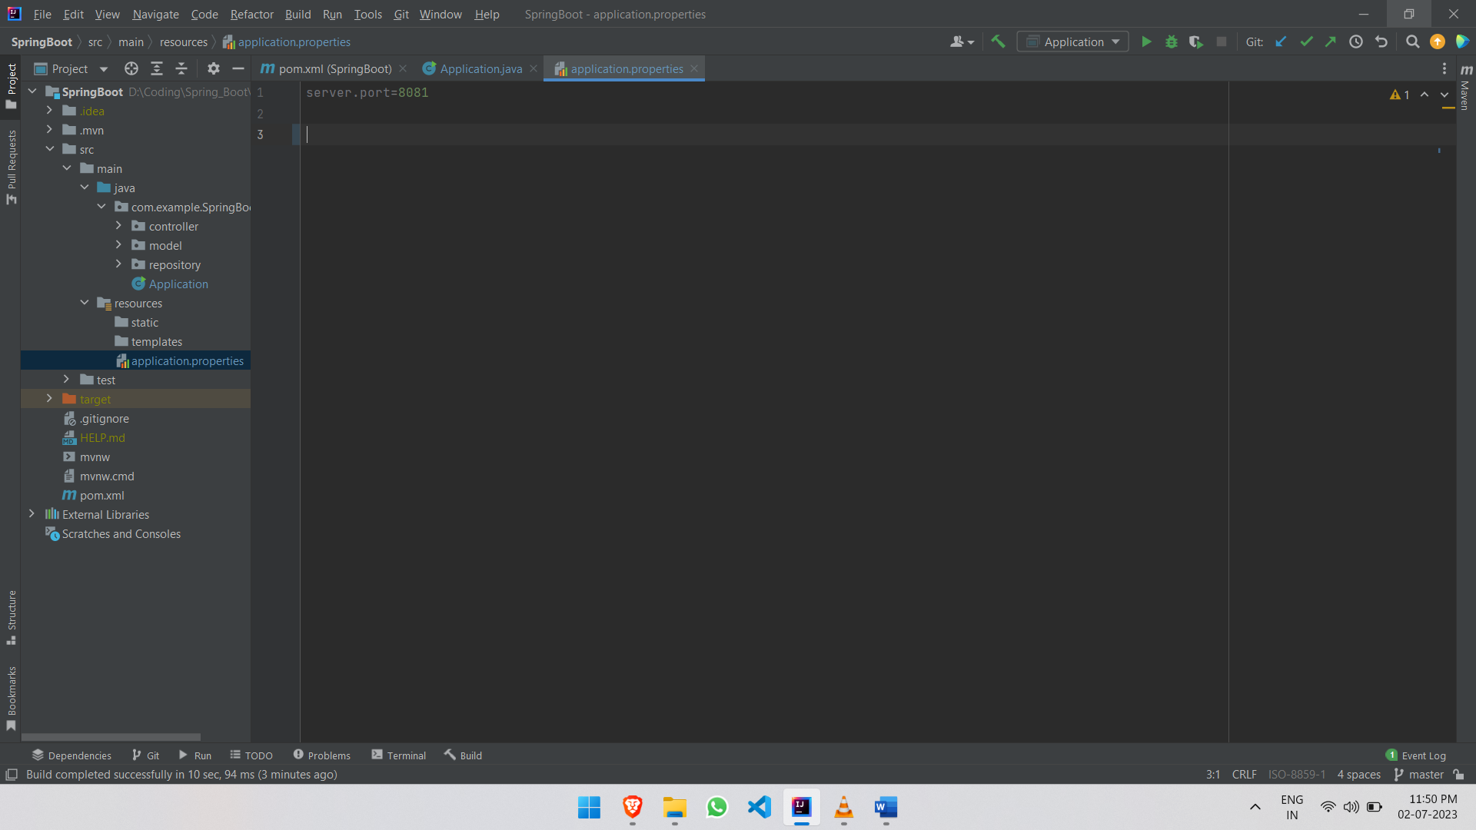

POST MAN

If we want to send some data with request then we use postman.

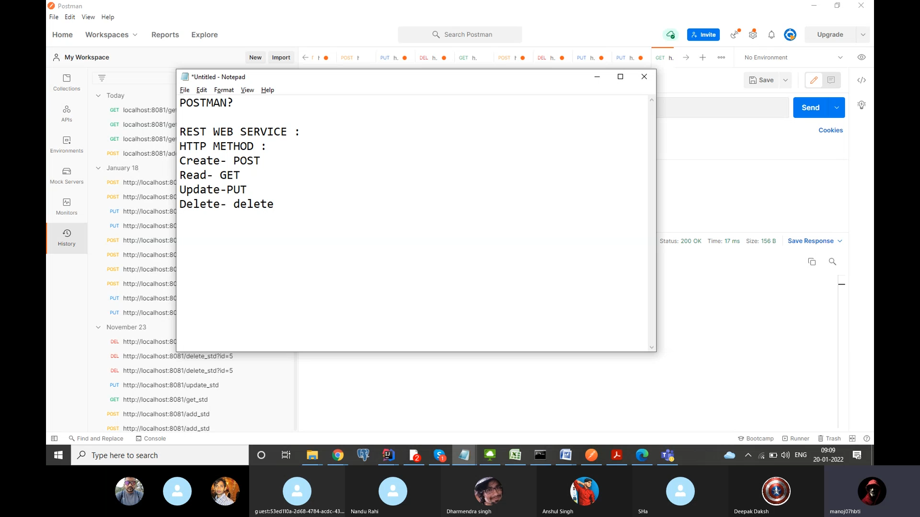

For sending data with request, we use @RequestBody annotation to receive whole object in request. Whereas in requestparam and pathvariable, we can only receive a single value in request.

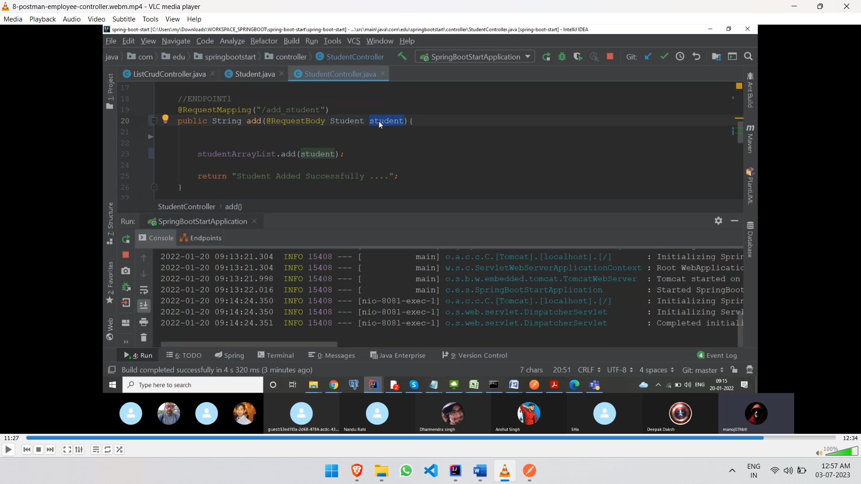

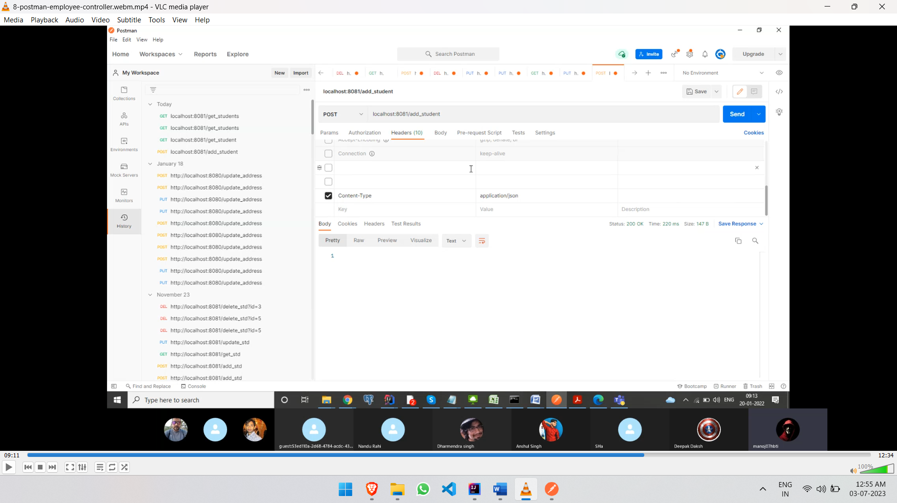

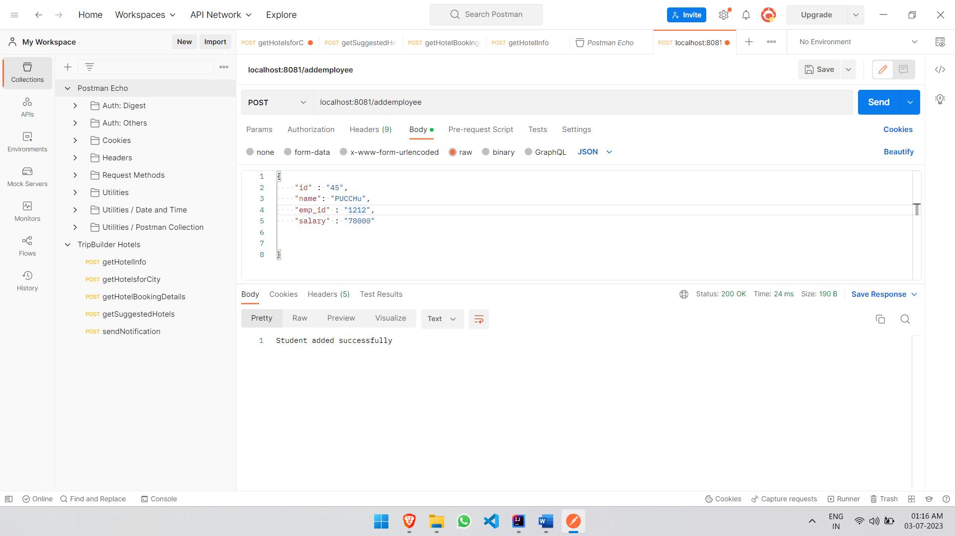

**Database**

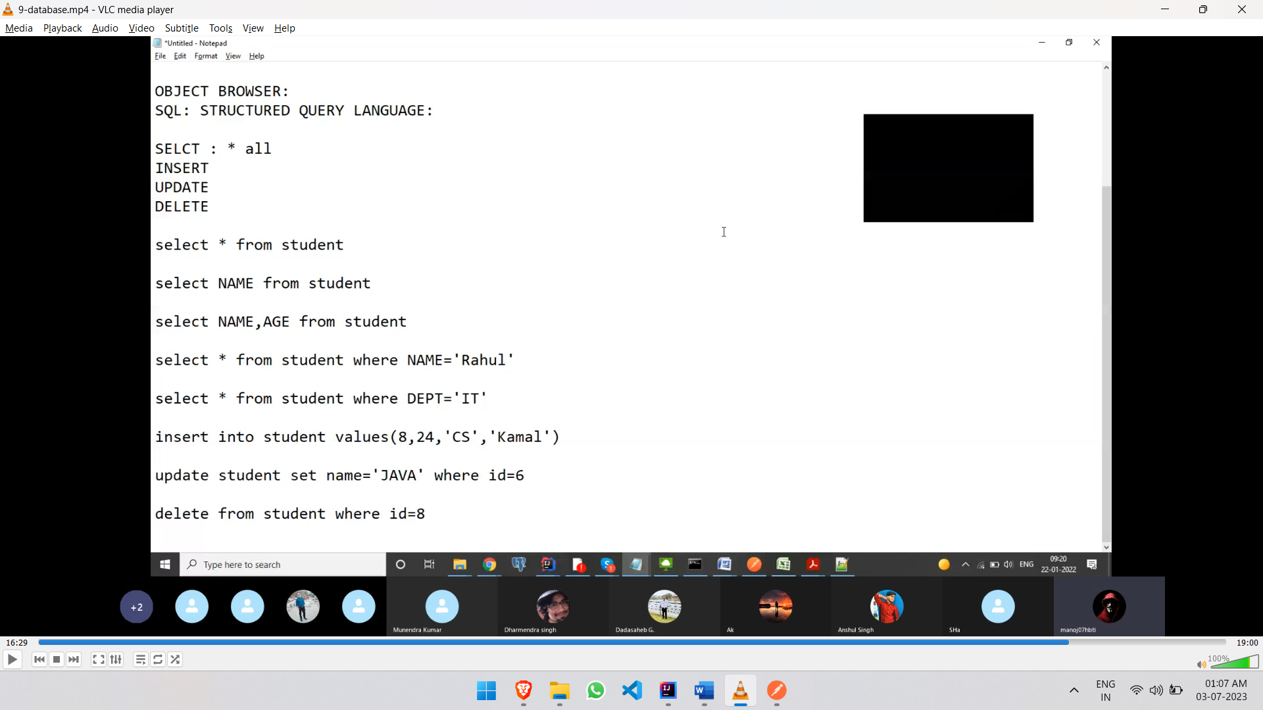

Integrating Database

1- Add these dependencies in pom.xml file

//1-Jis database ka connection bnana hai

<dependency>  
 <groupId>com.oracle.database.jdbc</groupId>   
 <artifactId>ojdbc8</artifactId>  
 <scope>runtime</scope>  
</dependency>

//2-It provides all methods related to database. All Crud operations are //writtein in this  
<dependency>  
 <groupId>org.springframework.boot</groupId>  
 <artifactId>spring-boot-starter-data-jpa</artifactId>  
</dependency>

Spring data JPA- JPA is an abstraction that is used to map the java object with the database. It provides all methods related to database. All Crud operations are written in this

2- Give database information in application.properties

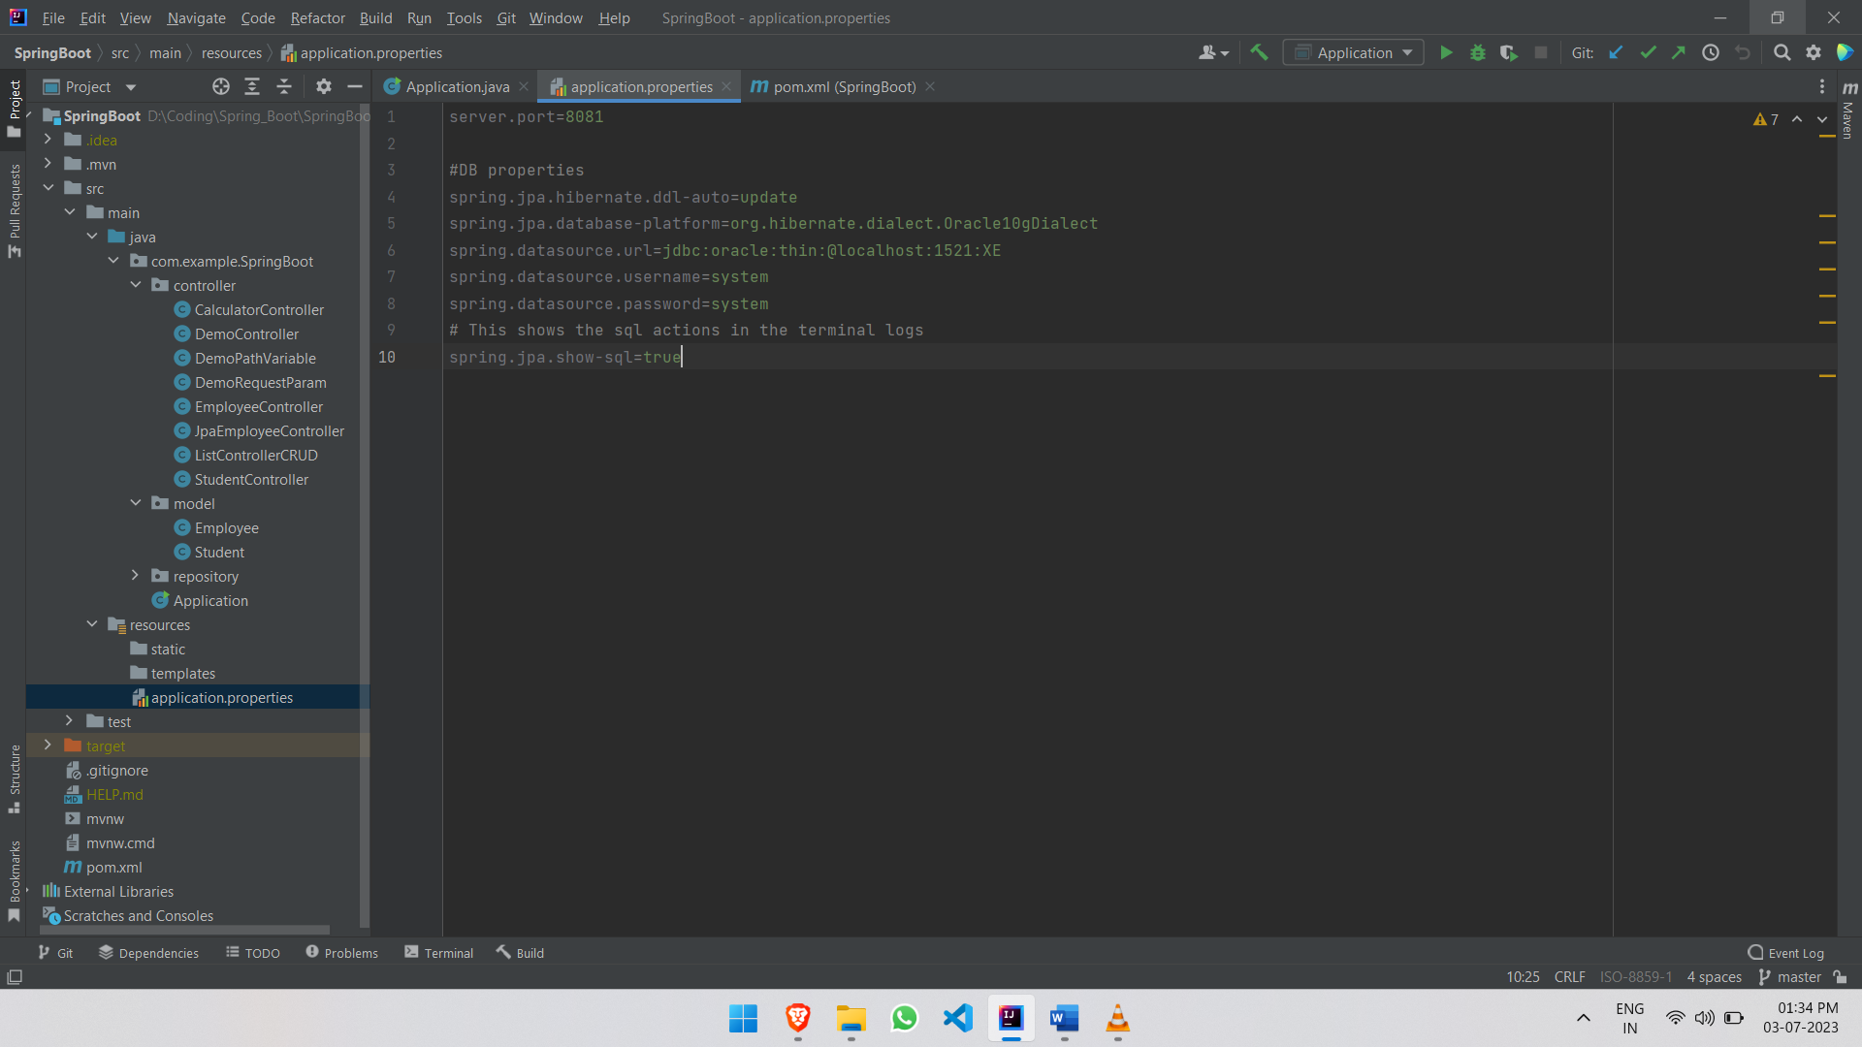

Hibernate: It is a core framework that make table from java code and perform operations like insert, update, delete

Hibernate is a java framework and ORM (Object Relation Mapping) tool that is used to provide the implementation of the JPA methods. How does JPA Work? JPA is an abstraction that is used to map the java object with the database.

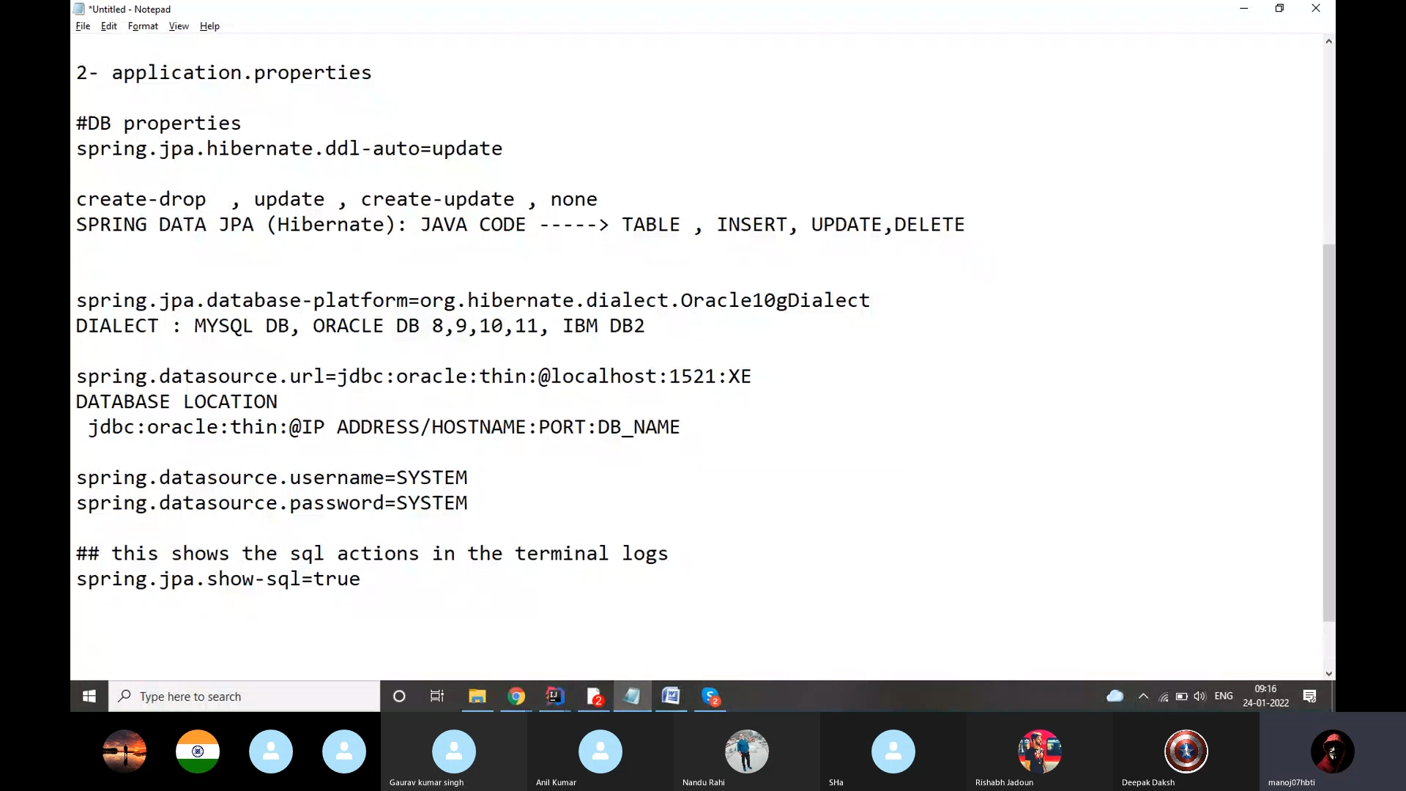

3-

1. Use @Entity to make Modal class as table
2. Set a column as primary key

@Id: to set as primary key

@GeneratedValue: Automatic value increment

1. Make default constructor of modal class

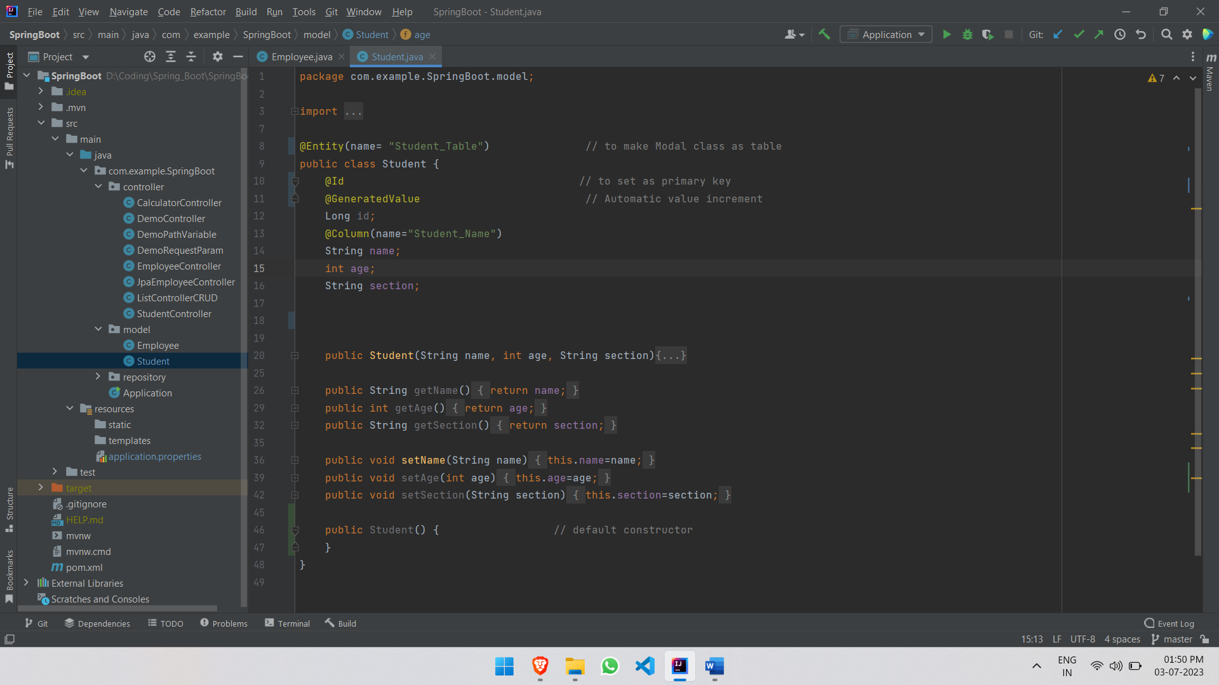

Adding data to database

1. Create JPA Repository (give the modal class name and the data type of primary key)

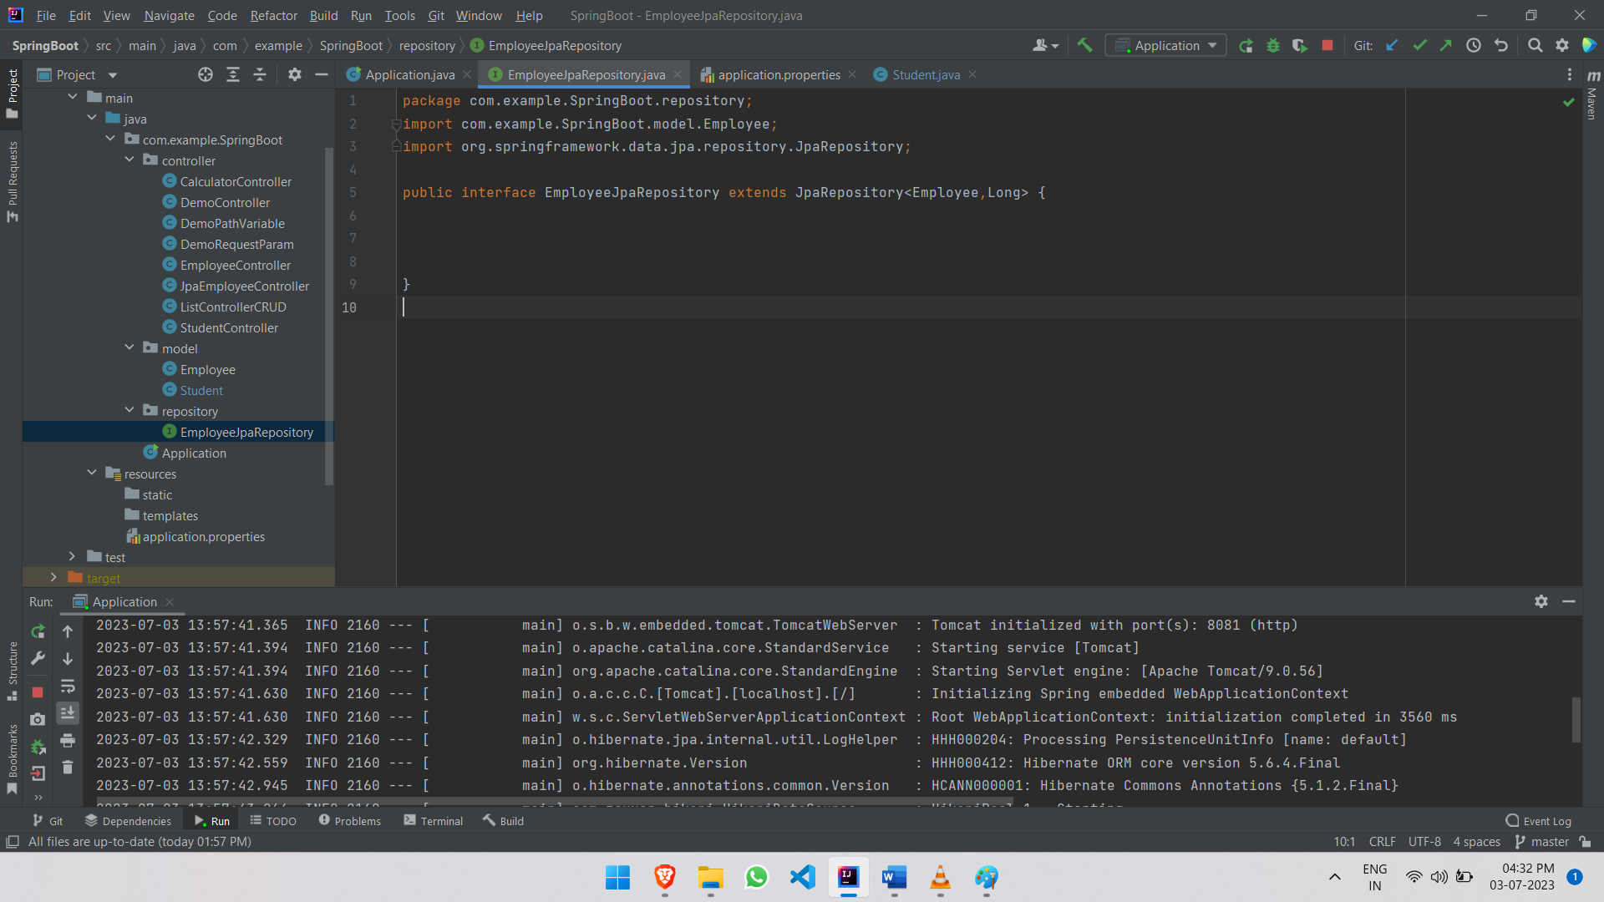

2- Create object of this repository class using @Autowired Annotation:

@Autowired  
EmployeeJpaRepository employeeJpaRepository;

